**Chinese Checkers Board Game**

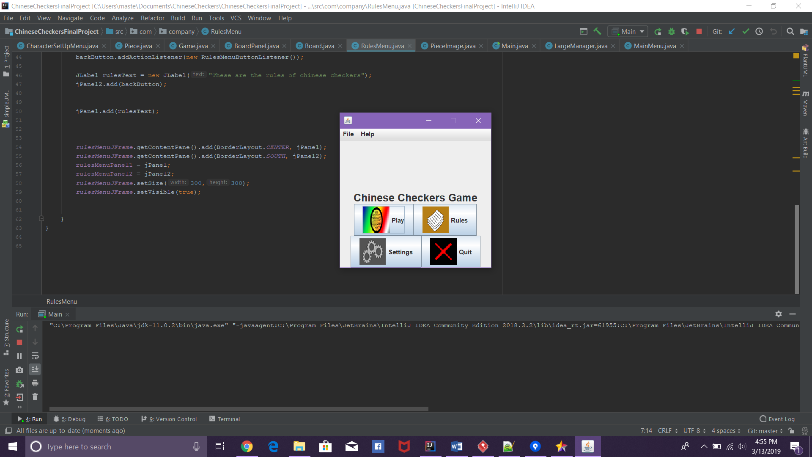

A fun board game that you can play with up to 5 of your other friends!

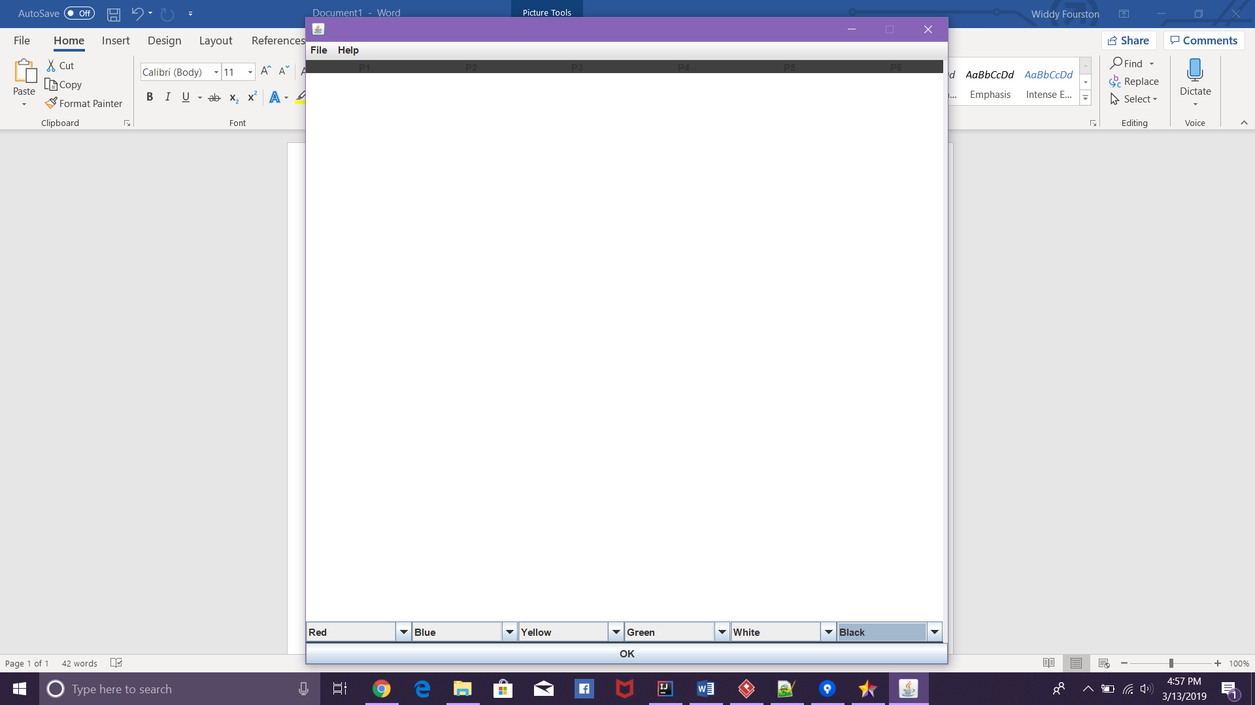

Learn the Rules! Pick your color! And skip to your heart’s content as you race to get to your opponent’s starting position!

